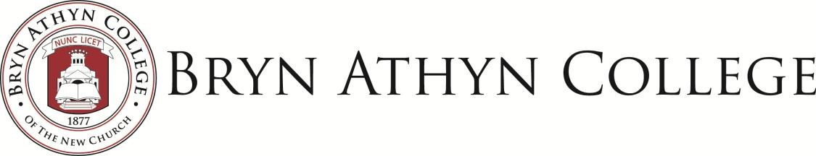

**Contact information for nearby lodging:**

**Fetters Mill Bed and Breakfast**

761 Fetters Mill Road

Bryn Athyn, PA 19009

info@fettersmillbedandbreakfast.com

#215-356-6303

([link)](https://www.fettersmillbedandbreakfast.com/)

**Courtyard by Marriott**

2350 Easton Road Route 611

Willow Grove, PA 19090

#215-830-0550

([link](https://www.marriott.com/en-us/hotels/phlwg-courtyard-philadelphia-willow-grove/overview/?scid=f2ae0541-1279-4f24-b197-a979c79310b0))

**Springhill Suites by Marriott**

3900 Commerce Avenue

Willow Grove, PA 19090

#215-657-7800

([link](https://www.marriott.com/en-us/hotels/phlwl-springhill-suites-philadelphia-willow-grove/overview/?scid=f2ae0541-1279-4f24-b197-a979c79310b0))

**Hampton Inn (Hilton)**

1500 Easton Road

Willow Grove, PA 19090

#215-659-3535

([link](https://www.hilton.com/en/hotels/wgvpahx-hampton-philadelphia-willow-grove/?SEO_id=GMB-AMER-HX-WGVPAHX&y_source=1_MjA4MjQ0MC03MTUtbG9jYXRpb24ud2Vic2l0ZQ%3D%3D))